**Steps To Run**

After clone or download the project, import it to any IDE.

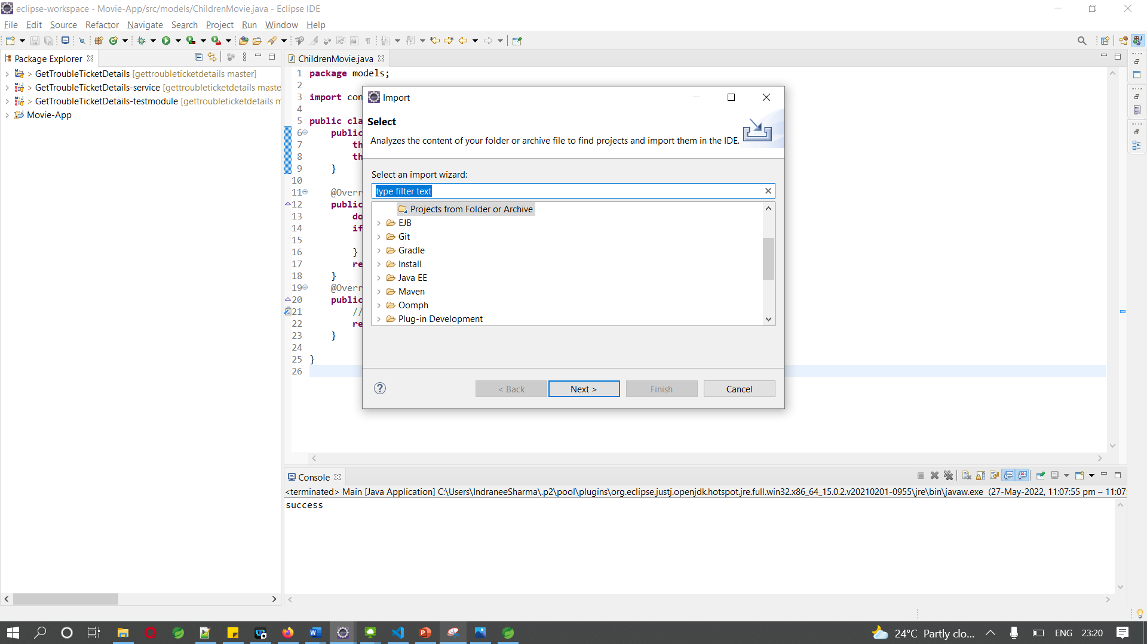

After Import add Junit5 jars

Run the Main.java.

**To run as a jar**

Go to bin folder and open command prompt. Run the below commands.

jar cvf program.jar -C bin .

java -cp ./program.jar models/Main